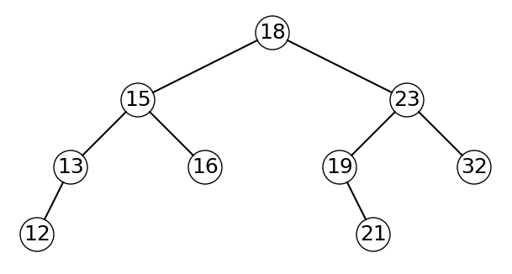

7

8

6

4

5

3

2

1

0

racine_fig1 = Noeud(18)

racine_fig1.insere_tout([15, 13, 12, 16, 23, 19, 21, 32])

8

6

5

4

2

7

3

1

0

racine_fig1 = Noeud(18)

racine_fig1.insere_tout([15, 23, 13, 16, 19, 32, 12, 21])